2024 Undergraduate Summer Research Program
Application Deadline: February 23, 2024
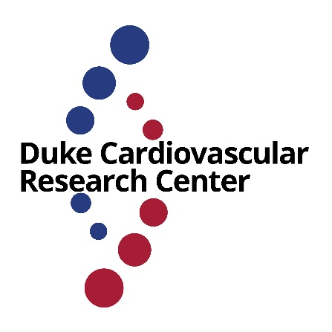
The CVRC Mandel Cardiovascular Undergraduate Research Experiences (CURE) call for proposals is open for Summer 2024. Six CURE Awards will be made to Duke undergraduates to participate in a cardiovascular research-oriented educational enrichment program. The program will be for at least 10 weeks of full-time research in a CVRC primary faculty laboratory, and includes a $4,000 stipend to help cover student accommodations and living expenses.

Eligible applicants must be current Duke undergraduates with an excellent academic record, who have conducted independent research with their proposed CVRC primary faculty mentor for at least one and preferably two or more semesters, and who demonstrate a strong interest in cardiovascular research. We strongly encourage individuals from under-represented groups to apply. Students will be selected for inclusion in the CURE program based on academic record, descriptions of research interests, and career goals.

Application materials should include a 1-page narrative with a description of the proposed project. Additional required application materials are a letter from the research mentor and a CV/resume for the undergraduate student. Although more than one applicant from a CVRC primary faculty lab may apply, it is unlikely that more than one awardee per lab will be selected. We will prioritize labs who have not previously had an undergrad supported by this program.

Applications are due on Friday, February 23. Decisions will be announced on or around March 1. Send any questions to Dr. Chris Holley (cholley@duke.edu) or Dr. Maria Price Rapoza (maria.rapoza@duke.edu).

Interested students should apply by submitting a PDF application to Dr. Maria Price Rapoza maria.rapoza@duke.edu, the Executive Director of the Duke Cardiovascular Research Center. Applicants will receive a notice their proposal has been received within 48hrs. If this notice is not received, applicants should contact Dr. Rapoza.

The specific days and weeks awardees are in the lab will be decided between students and their research mentor. However, awardees are required to be available during the weeks of May 20th (for welcome lunch and orientation) and July 22nd (to present their work).

Funding for this program is provided by the Edna and Fred L. Mandel Jr. Foundation. Note that any funds received by awardees will be considered reportable income by IRS rules (see https://finance.duke.edu/payroll/noncomp).

