2024 Supporting Undergraduate Research (SURE)
Application Deadline: March 22, 2024
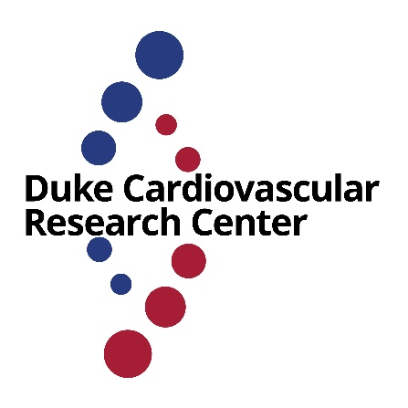
The CVRC AHA Supporting Undergraduate Research Experiences (SURE) call for proposals is open for Summer 2024. Three SURE Awards will be made to undergraduates to participate in a cardiovascular research-oriented educational enrichment program.

The SURE Program is hosted by the Duke Cardiovascular Research Center and is supported by the American Heart Association.
This 10-week summer experiences in cardiovascular research is designed for under-represented college students entering their sophomore, junior, or senior year who are exploring careers in Science, Technology, Engineering, Mathematics, and Medicine (STEMM). Students will present their research at a Duke CVRC flash talk seminar as well as at a AHA poster session at the end of the program.
These mentored summer research experiences are available to students from groups underrepresented in science. Awardees will be mentored by current cardiovascular researchers and AHA-funded scientists who are pursuing basic or translational research in cardiovascular disease. The Duke CVRC AHA SURE Summer Program is an excellent way for undergraduate students to garner a mentored research experience under guided mentorship from experts in the field of cardiovascular research.
- Learn the role of Cardiovascular Disease in Health: Discover what factors affect cardiovascular health and about research in Duke’s cardiovascular research laboratories.
- Gain Invaluable Experience and Mentoring: Work with a Duke cardiovascular researcher, sampling career paths and learning how research is conducted.
The AHA is committed to increasing diversity in science and in the delivery of health care. The program advances and promotes a rich academic experience for Scholars from historically underrepresented groups. We encourage careers in health services, research, community engagement and public service.
Eligible applicants should meet the following criteria--
- Candidate should have expressed interest in in biomedical research or health care
- Student could be pursuing a degree in any field, but must have interest in health care
- Student must be a full-time undergraduate, and be a rising sophomore, junior, or senior
- Student must have exemplary academic performance
- Student must be from an underrepresented group in science or medicine
Undergraduates who receive a SURE award will receive the following benefits--
- $6,000 stipend to help cover student accommodations and living expenses.
- Research experience in a Duke lab
- Mentorship on research, including how to present research data
- Opportunity to participate in an AHA scientific meeting
The application will include:
- A brief personal statement of approximately 500 words which addresses your scientific interests, your qualifications for the program, and how you believe this program will help you achieve your professional goals.
- Two letters of recommendation (if you have prior research experience, it will be helpful to have a letter from your research mentor).
- Unofficial transcript
Applications are due on Friday, March 22. Decisions will be announced on or around April 1. Send any questions to Dr. Sudarshan Rajagopal (sudarshan.rajagopal@duke.edu) or Dr. Maria Price Rapoza (maria.rapoza@duke.edu).

Interested students should apply by submitting a PDF application to Dr. Maria Price Rapoza maria.rapoza@duke.edu, the Executive Director of the Duke Cardiovascular Research Center. Applicants will receive a notice their proposal has been received within 48hrs. If this notice is not received, applicants should contact Dr. Rapoza.

The specific days and weeks awardees are in the lab will be decided between students and their research mentor. However, awardees are required to be available during the weeks of May 20th (for welcome lunch and orientation) and July 22nd (to present their work at the Duke CVRC flash talk seminar).

Funding for this program is provided by the American Heart Association. Note that any funds received by awardees will be considered reportable income by IRS rules (see https://finance.duke.edu/payroll/noncomp).

