Medicaid Reform Through a
Provider Led Framework Works
The Duke Outpatient Clinic is Duke’s largest safety net clinic for adults:
- > 5000 patients, 40% Medicaid, 10% uninsured
- Medically and socially complex
- Over 50% have co-morbid mental illness and substance abuse

HomeBASE Program
- Collaborative, team-based care model between patients, physicians, mental health providers, case managers, and social workers
- Focuses on our most medically and psychiatrically complex patients with the highest rates of Emergency Department use
- Effectively shifts care to non-emergent settings
- > $600,000 savings in first year

Mental Health
- #1 and #3 reasons for hospitalization in US
- LME-MCOs provide necessary services for our patients but it is unclear how their role will change under Medicaid reform
- Mental health care is fragmented and communication with primary care is poor. We support better integration of mental health care as a part of Medicaid reform.

Why will Provider Led Organizations succeed?
- Medicaid spending continues to rise in states that have authorized Medicaid HMOs
- NC Provider-Led Organizations retain NC funds for NC patients
- This benefits NC because delivery system is capitated for budgetary certainty; while fostering improved care management, patient safety, patient satisfaction
- Allows framework for implementation of uniform healthcare IT across NCPLO regions

Duke University Hospital Internal Medicine Residents – Ambulatory Care Leadership Track:

Matthew Atkins, MD
Jacob Feigal, MD
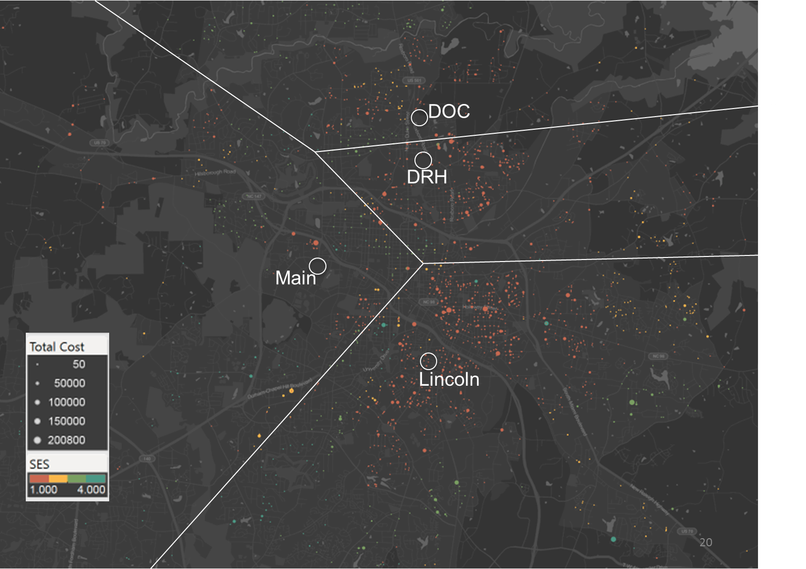
Ryan Jessee, MD
Claire Kappa, MD
Adrienne Klement, MD
Amy Jones, MD
James Lefler, MD
Aaron Mitchell, MD
Dinushika Mohottige, MD

Alex Cho MD, MBA (faculty)
Daniella Zipkin, MD (faculty)

